BOARD BIOGRAPHIES

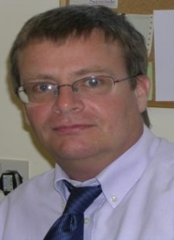
Dr Nick Hughes
I qualified in 1984 at the University of Liverpool. I worked in hospital medicine particularly psychiatry and paediatrics before going into general practice. I've been a GP partner in Farnborough for 22 years.

I've been involved in setting up and then working for Salus (GP federation) since early 2015. The aims of the federation have always been very clear: to provide high quality sensible services for patients and at the same time to make General Practice 'feel better' for those of us working within it.

I believe that the future of the NHS is dependent on sustainable general practice.

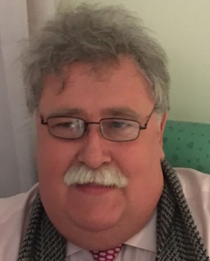
David Giles
I studied electrical engineering at Brunel University as a Ministry of Defence sponsored student and hold a postgraduate diploma in Accounting and Finance awarded by the ACCA. After graduation I spent 25 years in the Aerospace and Defence sector mostly involved in the development of computer based systems to operate in a variety of hostile environments which included warships, aircraft, railways, coal mines and many other industrial settings. I was offered my first board level appointment in 1988 and have held portfolios for Engineering, Sales & Marketing and Chief Executive. I am used to leading a multidisciplinary team and to working in customer facing roles to win and deliver contracts in businesses with formally accredited quality systems. In 2009 I joined Victoria Practice in Aldershot as Practice Manger and before joining the board of Salus Medical Services I served for three years on the NEH&F CCG Practice Council, gaining considerable experience in General Practice, the workings of the CCG and the wider NHS.

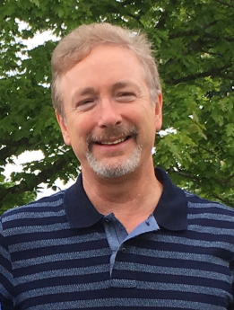
Dr Steve Scott Perry
I qualified in 1985 with MB ChB, BMSc (Hons) from the University of Dundee, then joined the University of Bristol three year GP vocational training scheme, obtaining the Diploma of the Royal College of Obstetricians and Gynaecologists in 1998 and becoming a Member of the Royal College of General Practitioners in 1990.

I have been a full-time GP partner at the Southlea Group Practice in Aldershot for 22 years. During that time I have been running a weekly GP minor surgery clinic and also a pain clinic utilising myofascial trigger point release techniques. I have GP trainer accreditation and have shared in the teaching of medical students, GP Registrars and more recently Paramedic Practitioners.

I have been involved in the setting up and running of our Salus GP federation six bedded “discharge to assess” (D2A) unit based at Ticehurst Nursing Home. The unit takes patients from Frimley Park Hospital, with a target stay of six weeks. During this time patients receive intensive input from GPs, occupational therapists, physiotherapists, social workers, nurses, and community reablement nurses prior to returning home or placement in a suitable nursing or residential unit. The aim is to reduce the re-admission rate, and the figures indicate this is being achieved.

I joined the Board of Salus Medical Services in the autumn of 2015. Recently I have been locality mentor for Salus Paramedic Practitioners. I believe the federation enables GPs to directly influence the future of primary care in their localities. Its aim is to improve both patient services and the working lives of the health care teams.

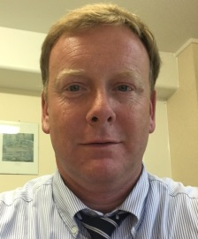
Dr Gareth Robinson
I’m married to the long suffering and eternally patient Jessica, with 3 teen and twenty-something children. I qualified as MBBS at St Georges Hospital, London in 1993 before gaining my Diploma of the Royal College of Obstetricians and Gynaecologists in 1997, and I became a Member of the Royal College of General Practitioners in 2010.

As a Partner in the Oakley Health Group, my day to day role includes GP training, and I’m the Locality Lead for Yateley. As a Director for Salus Medical Services I hold responsibility for the Integrated Care Lead role. I have a special interest in diabetes care.

My hobbies are horse riding, sailing, skiing and music – playing keyboards and piano, but also as a listener.

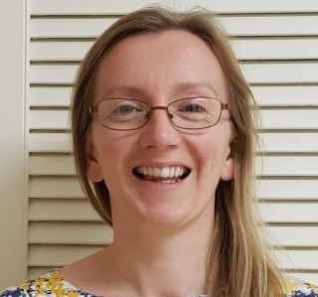
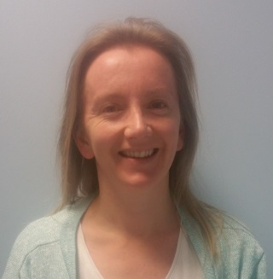
Dr Fiona Lowen
I qualified as a doctor in 2001 from Glasgow University (MBChB, BSc (MedSci) Hons) and Glasgow is my home city. All my hospital training (MRCGP (distinction), DRCOG, DFFP, DGM, DPD (merit) has been in Scotland and all my GP training and work has been in England, firstly beautiful Devon, and latterly in busy Hampshire and Surrey. Having spent time as a locum and salaried doctor, I then became a part-time partner at Farnham Dene Medical Practice in 2012 and continue to support the out-of-hours GP services at Frimley and Basingstoke by undertaking regular shifts.
Day-to-day I tutor the final year medical students from St George’s medical school during their GP attachment, and also supervise GP registrars during their out-of-hours GP work. At practice level, alongside general appointments, I am child safeguarding lead, provide female health and contraceptive services, and in-house dermatology.
As of August 2017 the Farnham locality has developed a local dermatology service for the population of Farnham with the aim of reducing wait times and workload for hospital dermatology. We manage most skin lesions and common dermatological conditions. Currently care is provided by a hospital specialist and myself.
Salus Medical Services has been busy since its creation in 2015 and my own GP practice has benefitted from the addition of a clinical pharmacist to our weekly patient service provision focussing on specific areas of chronic disease management and complex polypharmacy medication reviews. I am therefore delighted to join the Salus board and be involved in present and future ventures for the GP federation.

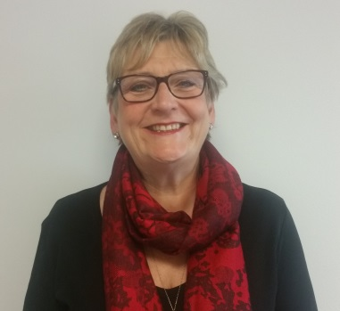
Sharon Boylett
As Associate Director of Nursing at Salus Medical Services, I bring over 30 years of experience in the local community, originally as a District Nurse, then as an Advanced Nurse Practitioner from 2004.
I see the primary role of Associate Director of Nursing as further advancing the Integrated Care team (ICT) by developing the staff and the service.
Following qualification as an SRN in 1977, I worked on both surgical and medical wards prior to completing an operating theatre nursing course. I decided to go back to the wards, so completed several years as a night sister at St Heliers Carshalton, then became ward sister, later unit manager, at St Peters Chertsey. I was privileged to serve as a commissioned officer in the Queen Alexandra Nursing Corps prior to joining the local community nursing service in 1986.
Having held multiple posts in the community whilst raising my family, I went to Alexander House Surgery in Farnborough as a relief district nurse in 1994 and never left!
Following completion of my Masters in Healthcare Management in 2002 I retrained as an advanced nurse practitioner, then did my non-medical prescribing training and still work as an ANP at Alexander House Surgery.
Throughout my years in the community, I have held various posts in commissioning, the most recent being for end of life care for the North east Hants and Farnham CCG, which I have now relinquished to spend more time on my work for Salus.

