New Opportunities: the Frimley Integrated Care System/Network Plans

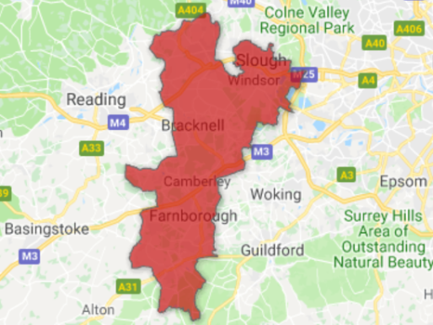

This autumn we will see important developments for local General Practice as the Frimley Integrated Care System progresses. We are presently attending locality meetings to introduce practices to ICS Network Plans. To reach as many people as possible we thought a newsletter may also be helpful.

What is Integrated Care?

The NHS is once again being re-organised and Integrated Care describes NHS provider organisations working together to provide patient care. The ambition is to move away from a system organised via contracts between commissioners and providers to a group of providers being given a budget to deliver outcomes for a local population.

The Frimley STP area (shown above) is one of eight pilot Integrated Care Systems nationally.

Why is it important that local General Practice is represented?

With Integrated Care, practices will be encouraged to work at scale with the other provider organisations and commissioners - CCG’s, community providers, mental health, social care, voluntary organisations and our local acute hospital. It will change the way that practices receive some of their funding. The core contract will continue to be negotiated nationally and paid direct to practices, but other income such as enhanced services may ultimately come via the new Integrated Care System.
New money coming into general practice is likely to come via this route and will be to support transformation and working at scale.

There is at present no local blueprint for what a local Integrated Care System will look like. Unlike when the CCG’s formed, setting up Integrated Care Systems (ICS’s) is not enshrined in legislation. General practice as the provider of by far the largest number of patient contacts must have a voice in determining what the local integrated care system will look like. Without representation, local acute hospitals, community trusts and other larger provider organisations will have the greatest influence on how care is organised and how local funds are allocated between providers.

Who represents your practice in Integrated Care?

There are now three provider GPs from local GP Federations on the ICS board and Salus has a seat at the ICS table, unashamedly on the side of local general practice. This maybe the best opportunity we have had for general practice to be involved in shaping the future.
What is a Primary Care Network?

There is a national drive to create Primary Care Networks in England ideally a Network should cover 30,000 to 50,000 patients. A Network can mean be a Super Practice, a large merged practice, practices working together via a Federation or just practices in a locality agreeing to work collaboratively.
In North East Hampshire and Farnham it has been agreed that we should continue working via the five Localities that delivered our local Vanguard program, so In NEHF a Network is synonymous with our localities (but this is not the case with the other ICS Networks).

There are now ten networks covering 100% of the population of Frimley Integrated Care System. These are: Aldershot, Bracknell and Ascot, Farnborough, Farnham, Fleet, Slough, Slough/SPA, Surrey Heath, Yateley, Windsor Ascot & Maidenhead

Our Network Leads are:
Aldershot | Dr Karen Robinson
Farnborough | Dr Nick Hughes (ICS Board Rep)
Farnham | Dr David Brown (work shared with Dr Liz Burren)
Fleet | Dr Steven Clarke (work shared amongst 4 Fleet GP’s)
Yateley | Dr Gareth Robinson

Delivering Primary Care Network Plans

We are being asked to provide a Primary Care Network Plan for each Network and to have at least an outline plan ready by October 1st. This feels a little like being asked to provide Locality Plans for the local Vanguard program. Back then, after consultation with the localities we wrote the plans and then presented them to the Vanguard Steering Group. However, the preparation of Network Plans will be an evolving process. Once outline plans have been prepared there will be a peer review meeting in October attended by Network leads, Federation leads and ICS staff. Not all our ideas will be supported but hopefully some will. We are told that ‘Investment into general practice will be aligned to our network plans’.

General Considerations

This is not an undercover attempt to load more things onto general practice. We have been involved in this process for some time now, we have encountered concern for the problems and a genuine desire to help general practice transform. There is a realisation that if general practice collapses so does the NHS.
The aim of the plans is to support the sustainability of general practice, make it a better place to work and ensure it has the capacity to offer the services needed to achieve the ICS wide plan. This will involve understanding our local populations, including variation in access and outcomes and the risks to local general practice.
The ICS/national priority areas are
- Mental Health
- Cancer
- Urgent and Emergency Care
- Children
- Prevention
(plus Transforming General Practice). However, the whole ICS themes will be drawn from our individual network plans; there will be a strong emphasis on reducing variations in care.
In return for investment we are being asked to facilitate a high level of engagement and buy in from all practices so that we can ‘put in place the foundations for the long-term stability of general practice through collaboration’ (at scale).
Is there funding for working up our Network Plans?
Each network will receive £5,687 plus an additional £1500 per practice. It is up to the networks to decide how this funding is used but must include: clinical leadership, production of the plan, communication and engagement with practices, community services partners and people within your community.
What must be in our plans?
Plans must be based on the Primary Care Maturity Matrix – see next page.

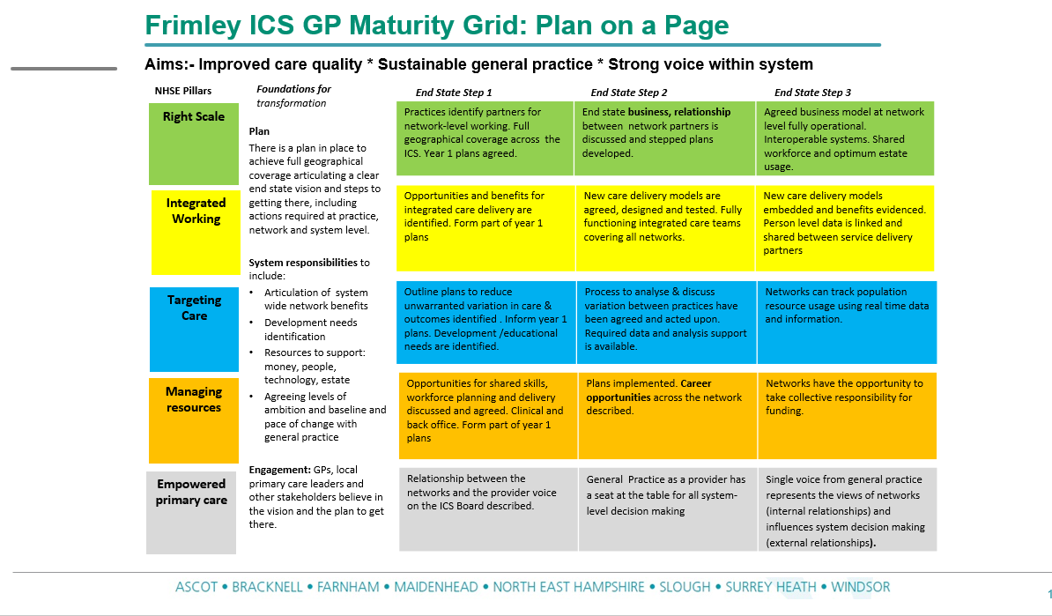

The NHSE Pillars – How we can build them locally

Right Scale
We are used to working within localities to deliver our locality plans through the Vanguard program. There have been mergers in Aldershot and Yateley and a merger is planned in Farnborough. Practices that still value their independence have also been teamworking, sharing staff employed by their Federation. Each Network needs to consider how they make collective decisions and what mandate they give to their network lead to represent the network’s constituent practices. Salus is offering to organise and be present at locality meetings if this is helpful; Aldershot will have a website so that those that cannot attend meetings can share their views.
Integrated Working
The use of the word integrated is becoming confusing, we have integrated care systems and integrated care teams already. In this context we need to consider our existing at-scale delivery models and how we will develop what we already have – for example, maintaining and developing our existing very highly regarded paramedic workforce. We anticipate more paramedics to cover annual leave, unscheduled absence and future absence for training. Integrated Care Teams are a ‘must do’ item. We are very lucky to already have successful ICT’s in all five localities but how would we like to see this develop/improve?
We are already working together to deliver extended access in all five localities but we are now also being asked about how we feel about urgent care models, we have two local examples of dealing with ‘on the day’ demand in both Farnham and Yateley.
Targeting Care
We are being asked to reduce variations in care and outcomes across networks. This involves describing and understanding our different populations and deciding where we should target interventions. We have information packs from the CCG. It should be emphasised that we only need to have decided on which areas we would like to focus on by October 1st. We are not being required to come up with detailed costed plans. We should also be clear that this cannot happen without adequate support and funding and that good interventions for patients should go hand in hand with making working in general practice feel better.
Managing Resources
How does the network aim to use working at scale as part of future workforce planning? We are lucky, having already made a start on introducing a skill-mix into general practice – how should this develop?
We have talked about supporting practices with back office functions – can we realise economies of scale. We have talked with virtually all the practice managers over the last couple of years – help with CQC has been a continual theme but there must be others. So far much of the work we have done has concentrated on reducing the load on our GPs but we must also be think about our very hard working practice managers and administrative staff.
Empowered Primary Care – having your say

We would value your views on the best ways for us to facilitate two-way communication between life at practice level and the ICS board.
It is widely accepted that there is a need to change the way General Practice works, and is funded, to make it a safe and sustainable place to work both now and for the future. The key points to remember are:
- Showing a united front will let us have an impact on planning that reflects the importance of our role and the scale of our interactions with the public
- Rather than seeing ICS as a risk, consider it an opportunity to significantly influence those changes.
- It will not happen overnight and we will need to continue to consult widely, to evaluate objectively and to implement what makes sense for us and our patients.
Transforming the way we work is difficult and of course much of what we currently do is excellent and should not be tampered with; but we have already seen what improvements can be achieved in our area through adding skill mix and working collaboratively - something that 5 years ago might have seemed impossible.
The ICS represents a new opportunity to build on this, not dismantle it and try something different as has so often happened in the past. This time we are developing and refining what we do, learning from successes and failures both locally and nationally, and most importantly we, the GP community, have a real opportunity to influence the future and raise the profile of General Practice in the local healthcare economy.

Let’s use this opportunity to ensure that developments are done with us, not to us!

Dr Nick Hughes
August 30th 2018

